DICE GAME

STAGE 1
Things the program should do
welcome user
Input user name
Start game
play diceSimulator
roll dice x 20
Display the result of each roll
Display game finished message that includes user name

STAGE 2
Display menu
Input choice – select game more descriptive
Play user selected game - play roll a six more incisive
Roll A six
Player starts with score of 5
roll dice
if not a 6 score -1
if roll six game ends with remaining score
if no 6 and score is zero player loses (while loop?)
User Case diagram
STAGE 1
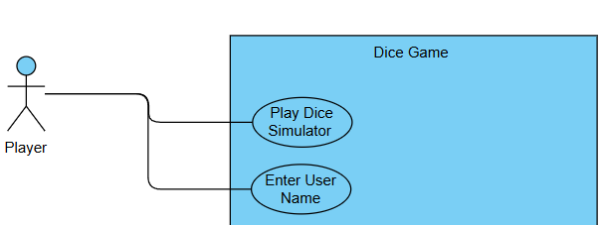
STAGE 2
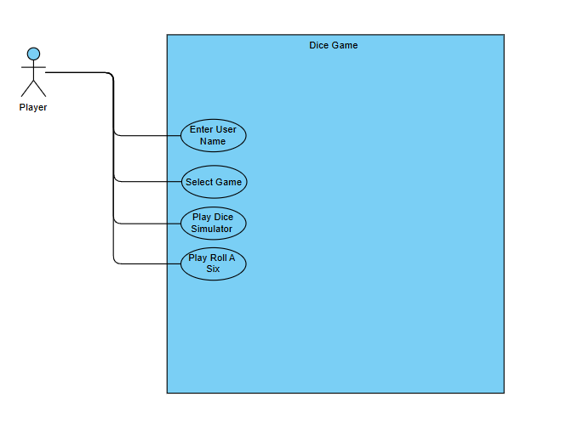
Had include display menu but was removed because it add nothing different as a use case
Normal flow only includes what the user sees and does. Aswell as what the system need to fufil the requirement. E.g here is store user name the user never need to know that but the system need to know this.

Use Case description

Enter user Name
Use Case ID | UC-01
Use Case Name | Enter User Name
Created by | Tommy
Actors | Player
Trigger | Player: starts program
Pre-condition | NONE
Post-condition | System:stores userName
Normal Flow | System: displays welcome message  System: prompts player for userName  Player: enters userName  System: stores userName
extends(alternative flow)
Includes

Play Dice Simulator
Use Case ID | UC-02
Use Case Name | Play Dice Simulator
Created by | Tommy
Actors | Player
Trigger | Player selects Dice Simulator
Pre-condition | System Username stored
Post-condition | System: userName and thank you for playing message displayed
Normal Flow | System: Display header  Repeats 20 time {System: rolls dice  System: displays result of roll}  System: displays userName and thank you for playing message
extends(alternative flow)
Includes
*added display header stage 2

Select Game
Use Case ID | UC-03
Use Case Name | Select Game
Created by | Tommy
Actors | Player
Trigger | System: userName stored
Pre-condition | System Username stored
Post-condition | System: game selected
Normal Flow | System: Displays menu  Player: enters selected game number  System: game selected
extends(alternative flow)
Includes | Display menu

Play Roll a six
Use Case ID | UC-04
Use Case Name | Play Roll A Six
Created by | Tommy
Actors | Player
Trigger | player: selects roll a six
Pre-condition | System Username stored
Post-condition | System: Display win or lose result
Normal Flow | Display: Display header  System: score set to 5  System: roll dice  System: display result  System: if result is 6 end game  System: else minus 1 from score and repeat until player rolls 6 or score = 0  System displays win or lose result
extends(alternative flow)
Includes

Play Roll a double
Use Case ID | UC-05
Use Case Name | Play Roll a double
Created by | Tommy
Actors | Player
Trigger | player: selects roll a double
Pre-condition | System Username stored
Post-condition | System: Display score
Normal Flow | Display: Display header  System: score set to 0  System: repeat 3 times  - System: roll dice  - System: roll dice 2  - Display the result of dice and dice 2  System displays final score
extends(alternative flow)
Includes

Class Responsibilities Collaborators
Main
Responsibilities | Collaborators
Does : | GameController
Creates: GameController | playGames.start()
Calls:playGames.start()
*Added at stage 2 was missing

GameController
Responsibilities | Collaborators
Create DiceSimulator | DiceSimulator
Holds: simulator (instance of DiceSimulator) | simulator.playDiceSimulator(userName)
Create RollASix | RollASix
Holds: rollASix (instance of RollASix) | rollASix.playRollASix(userName)
Create RollADouble
Holds: rollADouble (instance of RollADouble) | RollaDouble
Create Menu | rollADouble.playRollADouble(userName)
Holds: menu(instance of Menu)
Holds userInput(instance of Scanner) | Menu
Holds: userName | menu.startMenu(userInput)
Does:start
Does: displayWelcomeMessage
Does: getUserName
Does:startMenu
Does: playSelectedGame
Switch Case
- playDiceSimulator passing userName
- playRollASix passing userName
- playRollADouble passing userName

Does toString
*added userName during stage 2 crc
*amend selectGame change to playSelectedGame(more descriptive)

Menu
Responsibilities | Collaborators
Holds: userInput (Scanner received from gameController) | GameController  userInput.nextInt()
Does: startMenu(returns selected)
Does: displayMenu
Does: getUserSelection

DiceSimulator
Responsibilities | Collaborators
Create Dice | Dice
Holds: dice (instance of Dice) | dice.rollDice()
Holds: rollResult
Does: playDiceSimulator
(receives userName from Game Controller)
Does: displayHeader
- Action: Repeat 20 times
- Does: rollDice
- Does: displayResult number and value
Does: finishMessage using userName

DiceSimulator
Responsibilities | Collaborators
Create Dice | Dice
Holds: dice (instance of Dice) | dice.rollDice()
Holds: rollResult
Does: playDiceSimulator
(receives userName from Game Controller)
Does: displayHeader
- Action: Repeat 20 times
- Does: rollDice
- Does: displayResult number and value
Does: dispalyThankYou using userName

Roll a six
Responsibilities | Collaborators
Create Dice | Dice
Holds: dice (instance of Dice) | dice.rollDice()
Holds: score
Does: set score to 5
Does: playRollASix
(receives userName from Game Controller)
Does: displayHeader
- Does: rollDice
- Action: While score not 0 and roll not 6
- score – 1
- Does: displayResult roll and score
Does: Displays displayWinLoseResult using userName and score
*amend changed resetScore method to set method no required

Roll a double
Responsibilities | Collaborators
Create Dice | Dice
Holds: dice1 (instance of Dice) | dice.rollDice()
Holds: dice2 (instance of Dice)
Holds: score
Does: Does: set score to 0
Does: playRollADouble
(receives userName from Game Controller)
Does: displayHeader
Action: Repeat 3 times
- Does: dice1.rollDice
- Does: dice2.rollDice
- Does: displayResult dice1 and dice2
- Does: If dice1 and dice2 result are equal add 1 to score

Does: dispalyThankYou using userName and score
*amend changed resetScore method to set method no required

Dice
Responsibilities | Collaborators
Holds: rollValue
Does:rollDice

useCase stage 3
